Taskly

Project: App development

App Name: Taskly

Date : 18 February 2024

Introduction:

Taskly app as the name suggests is a task scheduling app that gives us a delineation ,of our to do list for a particular day and allows us to keep track of it depending upon the urgency and importance of the task.

Installation:

1) Download APK: Get the Taskly app from a trusted source.

2) Enable unknown Sources: Allow app installation from unknown sources in your device settings.

3) Install Taskly: Locate and tap the downloaded APK file to install Taskly.

4) Permissions: Grant necessary permissions

5) Launch Taskly: Find the app icon on your home screen and start using Taskly.

User Guide: Taskly’s simplicity allows you to add tasks quickly with just four details:

1) Task Title=>Briefly describe your task.

2) Task Description=>Add a brief task description.

3) Task Type=> Indicate the current task type.

4) Task Status=>Indicate the current task status.

To add task:

1) Open Taskly.

2) Fill in Title, Description, Type, and Status.

3) Save your task

A delineated version has been put below for reference:-

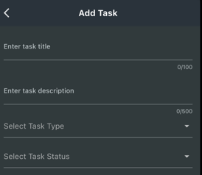

: 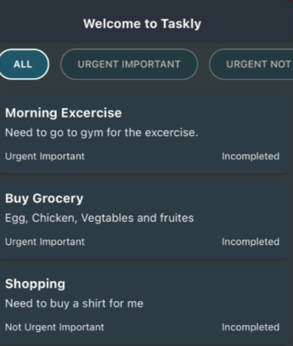  
Troubleshooting:

1. Adding task issue:

Solution: Fill all required fields, restart if needed.

1. Task not saving:

Solution: Tap “Save”, retry with a stable connection, or restart.

1. App Crashes Editing Task:

Solution: Update app, contact [[psakhil211@gmail.com](mailto:psakhil211@gmail.com) ] if issues persist

1. Task Status Issue :

Solution: Update app, check connection, or device settings.

1. Missing Tasks:

Solution: Log out, log in, check for updates, or contact support.

Contact us:

If you encounter any issues or need further assistance, please contact our support team

Email : [ [psakhil211@gmail.com](mailto:psakhil211@gmail.com) ]

Thank you for choosing Taskly to manage your tasks more efficiently. We hope Taskly can give you a more productive and organized experience!!

Happy Tasking!!!!!!!!!!!